F R I E N D S O F S T. M A R G A R E T’S C H U R C H - CIO

MINUTES OF THE TRUSTEES MEETING OF THE FRIENDS
OF ST. MARGARET’S CHURCH - CIO, HIGH HALSTOW. HELD
ON TUESDAY 27TH SEPTEMBER 2022 at 7.00PM IN ST. MARGARET’S CHURCH, HIGH HALSTOW

TRUSTEES PRESENT: Mike Meredith (Chairman)
Raymond Collins (Treasurer)
Chris Cook (Minuting Secretary)
June Collins
Maggie Ryan (Correspondence Secretary)
Jane Cook
Carole Cocup
David Lapthorn

ALSO PRESENT: Chris Peek (Membership Coordinator)

APOLOGIES: Rev. Stephen Gwilt
Tamsin Stowers
Mitchell Dowsett
George Crozer

MINUTES OF THE MEETING HELD ON THE 25th APRIL 2022:
The minutes of the meeting had been circulated in advance.
The chairman reviewed the minutes.
There being no amendments, it was proposed to accept the minutes.

Proposed by Jane Cook
Seconded by Carole Cocup The vote to accept the proposal was unanimous.

They were then signed by Mike Meredith (Chairman) as a record of the meeting.

MATTERS ARISING FROM THE MINUTES, NOT LISTED AS A SEPARATE AGENDA ITEM:
There were no matters raised.

FINANCE:
Raymond Collins (Treasurer) gave an update on the FOSM Accounts up to 26th September 2022. The detailed reports are attached to the minutes as addendums.

As a summary, we currently have 45 members who pay their subscription monthly and 3 members who pay annually.

The bank balance is £32,427.40, of which £30,904.85 is ‘protected’ for roof repairs. The remaining £1,558.16 is not ‘protected’ and therefore available for general expenditure.
Page 1
Mike Meredith asked how our current income compares to previous years? The treasurer replied that the current half year income exceeds that of the half year in 2021.

Mike Meredith has undertaken a review of income and expenditure since 2012. He highlighted the excellent news that subscriptions have greatly increased from approx. £800.00 in 2012 to approx. £7,000.00 expected in 2022.

CORRESPONDENCE:
Maggie Ryan confirmed that a letter from the PCC of High Halstow, Allhallows and St Mary’s Hoo thanking the Friends of St Margaret’s for our continued contributions towards the repairs of St Margaret’s had now been distributed to all.
A copy of the letter is attached to these minutes as an addendum.

MEMBERSHIP:
Chris Peek informed the meeting that she has updated our FOSM leaflet, so that the relevant details concerning the FOSM were correct, including details of how to contact the membership coordinator (Chris Peek) for details of how to join the FOSM. This excellent idea has allowed us to continue to use our stock of leaflets.
Trustees were given a number of the updated leaflets, for future use.

PUBLICITY AND COMMUNITY LINKS:
Letters to the HH Times. The chairman wanted to highlight the achievements since our last meeting, of a number of articles regarding our church and the work of the FOSM in the HH Times. Thanks to Mitchell Dowsett, David Lapthorn and of course Mike Meredith for interesting and entertaining articles.
Mike Meredith then discussed a note he had received from Mitchell Dowsett who was unfortunately unable to attend the meeting, encouraging other FOSM members to provide further stories for inclusion in the HH Times.
Jane Cook then confirmed that she has sent Mitchell a story and picture for him to use. Briefly it concerned a couple from Maidstone who recently came to St Margaret’s Church to celebrate on the same day and time their wedding of 60 years ago.
David Lapthorn reminded Mike Meredith that he had previously indicated that he would write an article about the FOSM for inclusion in the HH Times. Mike Meredith confirmed that he would be writing an Autumn Newsletter, which apart from inclusion in the HH Times, would as normal be distributed to all FOSM.
This will also be sent to George Crozer who will include it in our website.

FABRIC OF ST MARGARET’S CHURCH:
- Update on agreed building works. The work has been completed, apart from a small area of pointing which could not proceed because of nesting birds. This work will be completed before the next bird nesting season.
- Replacement of temporary felt roof. At our last meeting it was agreed that we would ascertain from Heritage England, Medway Council and the Diocese if we could replace the temporary roof with Zinc rather than Lead, as Zinc has already been
Page 2
used in an area adjacent to the temporary roof. Raymond Collins informed the meeting that after consultation a member of the Church Diocese has confirmed that we have to use ‘Lead. Jane Cook asked if this has been confirmed in writing, apparently not, therefore Jane asked if we can have this decision in writing.

It was then agreed that we would ask David Jarret to provide a specification for the replacement of the temporary roof with a lead roof covering. Everybody is aware that the planning permission for the temporary roof expires in March 2024.

- Roof Alarm.
Jane Cook updated the meeting on this issue. The PCC have agreed to proceed with the roof alarm quote provided by Cactus. Jane Cook has applied for funding for this project from the Friends of Kent Churches. If successful the funds will be allocated in January 2023.
Note: the proposed system is wireless linked to a router within the church, which connects to a 24/7 manned control room, who will decide if the alarm requires investigating. If so they contact the relevant company / person. It has not at this time been decided who will be the point of contact.

- Recommendations for building work funding.
Mike Meredith asked the question ‘now that the building is weatherproof, what next?’ After some discussion is was agreed that Maggie Ryan and Mike Meredith would write to the PCC thanking them for the letter to all friends and asking them to consider what support they would like in the future from the FOSM and to itemise any proposals in order of their preference.
Raymond Collins then reminded the trustees that if we are to fund future projects the example that we have ‘protected funds’ for the replacement roof, could be used again.

- Organ restoration fund.
Maggie Ryan informed the meeting that the PCC have asked the FOSM if they would agree to administer a ‘protected fund’ for this project. After much discussion, Raymond Collins (Treasurer) indicated that this would not be an onerous task and that he would be prepared to oversee this fund within his treasurer’s remit.
It was then agreed that the FOSM are happy to administer the organ restoration fund and for this decision to be conveyed to the PCC.
Any monies raised will initially be used to fund a survey of the organ by Alastair Curtis to ascertain what works are required and how much they are likely to cost.
Carole Cocup then informed Maggie Ryan that she would like to make a donation to this good cause.

Page 3
- Update on Lychgate restoration (PCC)
Jane Cook informed the meeting that this PCC project is now ready to proceed and although there are a high number of stipulations from the War Memorial Trust that the project has to meet, they have agreed a quote from B W May and Son Ltd and that once faculty has been granted an order will be placed.
Jane reminded the meeting that the before the work commences the adjacent trees will need to be professionally pruned. The Parish Council have agreed to fund this work, but a date has not yet been finalised.

- Toilet / Kitchen project (PCC)
June Collins updated the meeting on this PCC project.
The PCC have financed a survey of the proposed location for this building and the information is now with the architects to enable them to finalise their drawings.
The cost of the project is substantial and is likely to take some time to finance. This a long term project which would benefit all users of the church.

REVIEW OF EVENTS HELD:
- Scarecrow festival
The scarecrow festival was held again this summer. Although not as well supported as some previous years it did raise £325.00, including gift aid.
Mike Meredith confirmed that this festival which highlights the FOSM, should continue in 2023, but with tighter and clearer goals. He has volunteered to oversee next years festival, but would like at least one volunteer to assist him.
If you would like to help Mike please contact him directly.

- Garden Party
The FOSM stall, was well positioned and attracted many visitors, both for the free games, with small prizes and a competition to guess the weight of the fabulous cake, expertly made and donated by Tamsin Stowers.
There is no doubt that improvements to our stall following on from lessons learnt at the Jubilee Fair paid dividends. Thank you to those who manned the stall, especially Chris Peek who also oversaw the prize giving.

- Welcome Event
This was not as well attended as many had hoped for, it was suggested that there were more stallholders than attendees. The date chosen probably did not help, but if another event is held it was agreed that the FOSM should partake.

- Jubilee Fair.
Unfortunately the FOSM stall was not in the best location, although the marquee we were in certainly kept some of the cold wind at bay!
Although another Jubilee fair is unlikely in the near future, the FOSM would again be in attendance were a fair to be organised.

Page 4
- Jubilee Concert.
A lovely concert, which should have had more attending than there were. After agreeing the date it was subsequently discovered that Allhallows Church was also having a concert at the same time.
This unfortunate clash has at least led to Louise Kennett volunteering to administer a diary for the churches. The aim is prevent a similar occurrence in the future. All events should be discussed with Louise before a final date and time is agreed and advertised.

FORTHCOMING EVENTS AND FUTURE PLAN:
- Scarecrow festival.
As already mentioned, another festival will occur in 2023.

- Christmas fete / market
The PCC have organised an Arts and Craft fete in the church, which will occur on three consecutive Saturdays, commencing 1st October.
The Christmas market will take place in the village hall on Saturday 3rd December, from 11.00am.
There will be a FOSM stall, where Raymond Collins will again be selling the very popular FOSM Christmas Cards. Chris Peek and Chris Cook have also agreed to assist with managing our stall.

- Autumn and Christmas Concerts.
The community choir are organising further concerts. The first is likely to be in November. They will also be appearing at the Christmas market on the 3rd December. Some dates and times have not been confirmed. Maggie Ryan has agreed to liaise with FOSM when dates are announced.

- History Talks
Maggie Ryan has confirmed that there will be another history talk, but details are still to be finalised. Date / Time t.b.c.

CHARITY COMMISSSION SUB GROUP:
Our charity commission details have been kept up to date by the chairman, who checked before the meeting to confirm that the details were all correct.
All details about our charity status can be found on the Charity Commissions website.
If you want view the details you will be asked to enter our charity website number which is 1189941.

Page 5
SAFEGUARDING:
Maggie Ryan confirmed that if you are working with children you must have safeguarding training.
Mike Meredith asked Maggie if all members of the trustees require safeguarding training and DBS checks, Maggie said it is not required, however there is safeguarding training. Chris Cook has the safeguarding pdf file, which he is happy to forward to those who request it.

ANY OTHER BUSINESS:
Jane Cook highlighted the fact that we had not discussed the Christmas tree festival. Do we want one in 2022?
It was agreed that we would like to see the lovely Christmas Trees in the church during the Christmas period.
Raymond Collins then volunteered to manage the Christmas tree festival. He expects it to commence on the 10th December and continue until Christmas. Many thanks Ray.

DATE OF THE NEXT MEETING:
The next Friends of St Margaret’s Trustees meeting will be in the church on Tuesday 21st February at 19.00.

There being no further business, the meeting closed at 9.15pm.

SIGNED: DATE:

Page 6

ADDENDUMS
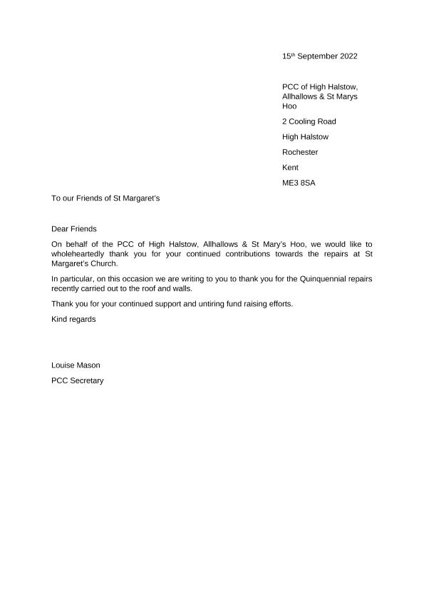

Page 7
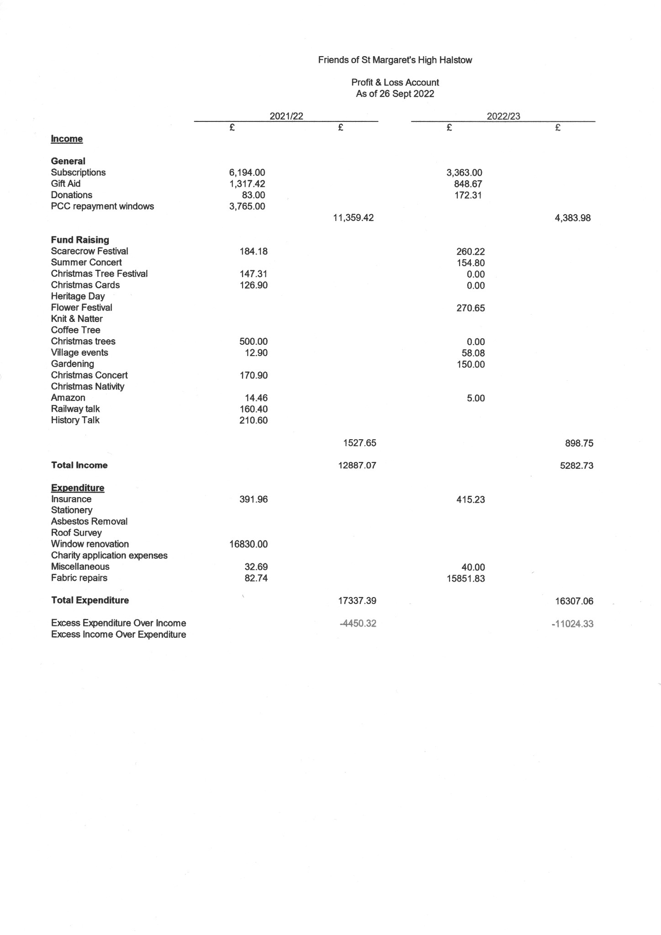
Page 8
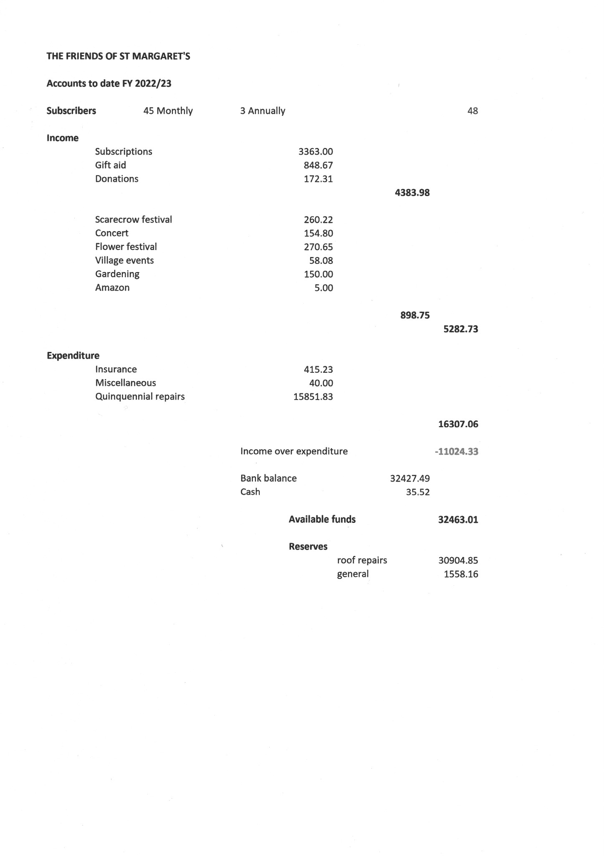
Page 9

