FRIENDS OF ST. MARGARET’S CHURCH - CIO

MINUTES OF THE ANNUAL GENERAL MEETING OF THE FRIENDS OF ST. MARGARET’S
CHURCH-CIO, HIGH HALSTOW. HELD IN THE CHURCH ON 25th APRIL, 2022.

IN ATTENDANCE:
Mike Meredith, Maggie Ryan, Carole Cocup, Ray Collins, June Collins, Chris Cook, David Lapthorn, Mitch Dowsett, Jeanette Dowsett, Jane Cook, Mary Hassell.

APLOGIES FOR ABSENCE:
Chris Peek, George Crozer, Tamsin Stowers, Margot Sturt.

MINUTES OF THE ANNUAL GENERAL MEETING HELD ON 24TH MAY, 2021.

The minutes of the meeting had been circulated in advance.

The chairman gave an overview of last year’s AGM minutes.

He highlighted the fact that our website had not been as up to date as had been expected when noted at last year’s AGM meeting. He has recently discussed the issue with George Crozer who administers our website on behalf of the FOSM. Thanks to George’s efforts he is please to inform the meeting that the website is now much more up to date.

The chairman also discussed our ‘Facebook’ contacts and how to improve them. Although no answer was forthcoming at our meeting, it was subsequently discussed at our Trustees meeting, where it became clear that one of the main issues was the limited number of facebook users who were ‘liking’ posts, which meant that we were are currently not able to exceed the number that ‘Facebook’ set to improve our coverage.

There being no amendments, it was proposed to accept the minutes.

Proposed by Ray Collins
Seconded by Maggie Ryan

They were then signed by Mike Meredith (Chairman) as a record of the meeting.

MATTERS ARISING FROM THE MINUTES THAT ARE NOT SEPARATE AGENDA ITEMS.

There were no matters raised.

CHAIRMANS REPORT.
The chairman then summarised his Spring 2022 report that had already been circulated in advance.

He wanted to highlight the Remembrance Sunday door decoration (pictured on page 2) that had been constructed by June and Ray Collins. All agreed that the decoration was ‘Superb!’

The High Halstow Christmas cards had been well received, once again thank you Ray Collins.

The Christmas Tree sales had exceeded expectations thanks to much hard work by Tamsin Stowers

Page 1
The St Margaret’s Church Window Restoration Project has now been completed. As highlight in his notes, the chairman would like to thank everybody involved. This has been a project to be proud of, whose success has been achieved by the support of our subscribing members, the fund managers and not to forget individual benefactors.

The Christmas Tree festival went ahead and added to the festive atmosphere of the church.

The Restoration works previously agreed are now well underway. They include Stonework repairs, Repointing, Galletting, Guttering, Downpipes and Joinery repairs to the Belfry louvre windows.

The Jubilee Concert with the High Halstow community choir is on Saturday 28th May 2022.

The village ‘Queens Jubilee’ celebrations will be on Saturday 5th June. The Trustees will have a stall and are looking for volunteers who can give some time to assist. The chairman is unfortunately unavailable, Chris Cook has agreed to be a contact for our stall.

The Flower festival in the church will take place from the 2nd – 5th June. Full details of how to help in the chairman’s report.

The chairman would like to remind all trustees that Amazon have confirmed that ‘The Friends of St. Margaret’s’ have been registered with Amazon Smile. Those who use Amazon can nominate us as their charity. This means that 0.5% of all spend is donated to our (FOSM) charity. It is entirely up to individuals who they nominate, but if you are not registered please consider the FOSM

Finally, please remember that our membership and subscriptions are the backbone of our funding.
Recruitment of members is a priority.

FINANCIAL REPORT.
Ray Collins (Treasurer) then presented the financial report.

Subscriptions. We now have 49 subscriptions, having lost three but gained two over the last year.
Subscription income increased by 16% to £6,194.00

Note: The accounts have been audited.

The Chairman thanked Ray Collins for his continued work as Treasurer.

The full financial report is attached as an addendum, at the end of the minutes.

COMMITTEE MEMBERS FOR THE COMING YEAR.
The chairman confirmed that the Trustees will have to be formally reviewed by February 2023.

AOB.
Safeguarding.
The chairman expects all trustees to be aware of safeguarding.

There being no other business the Annual General Meeting was closed at 7.40 p.m.

Page 2

SIGNED:

DATE:

ADDENDUM:

THE FRIENDS OF ST MARGARET’S CHURCH CIO ACCOUNTS BELOW

Page 3
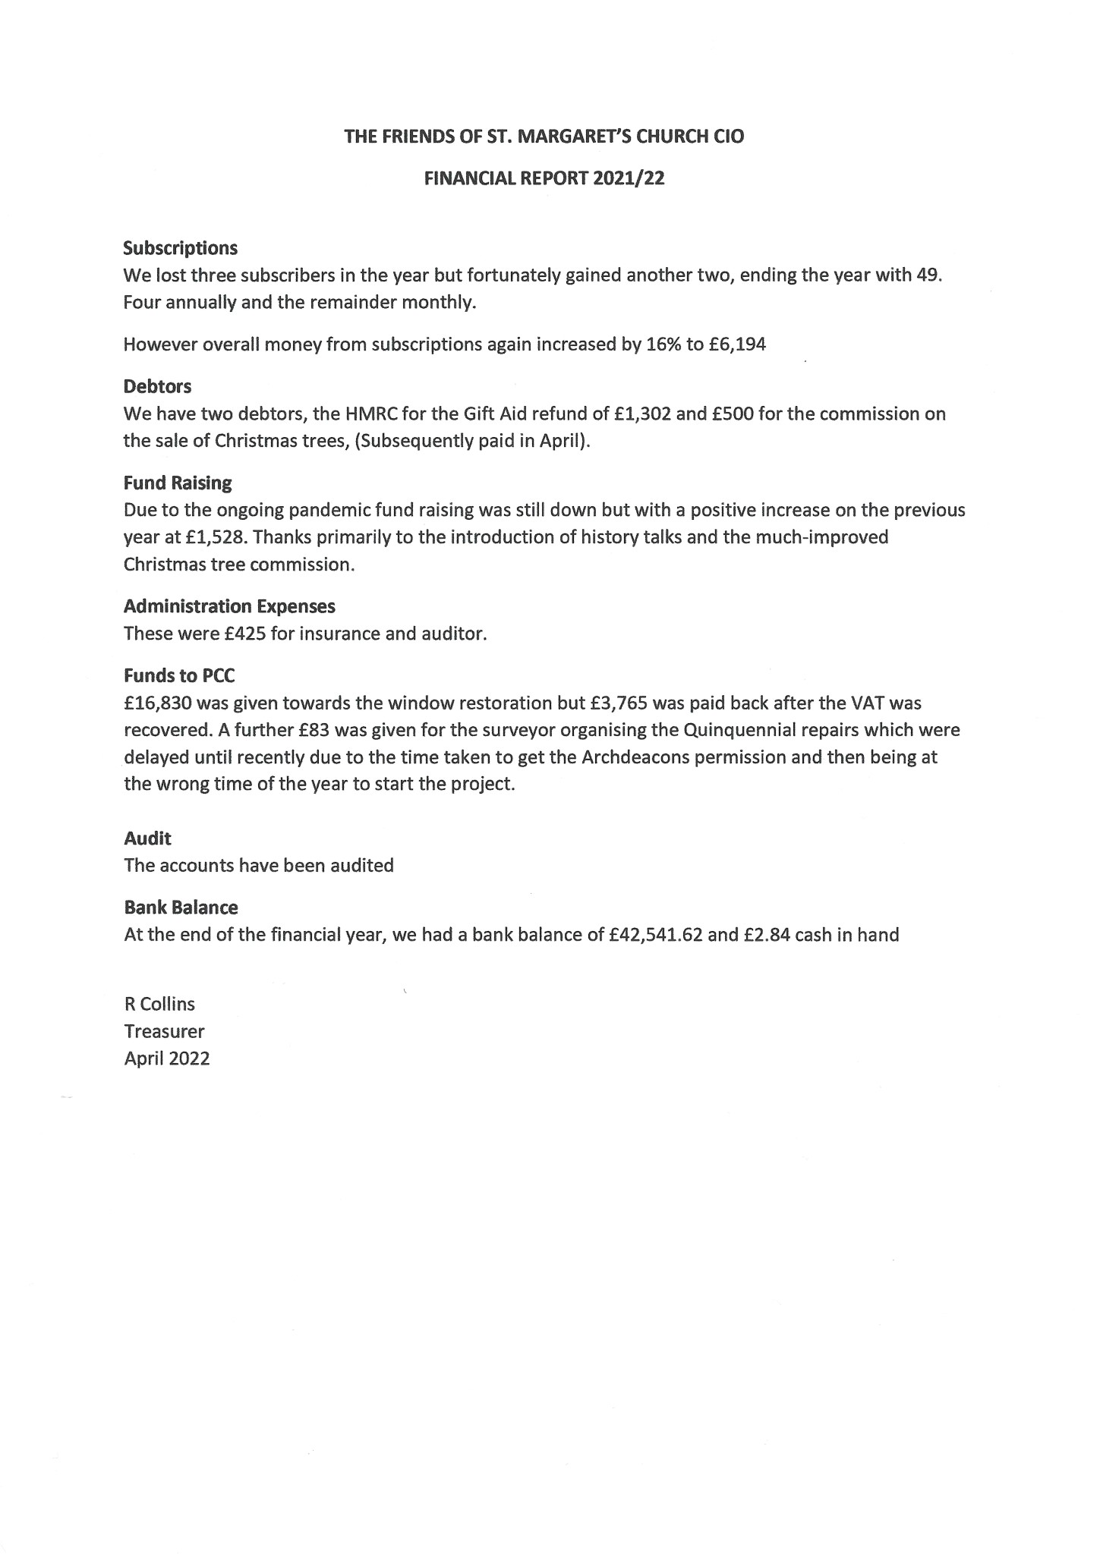
Page 4
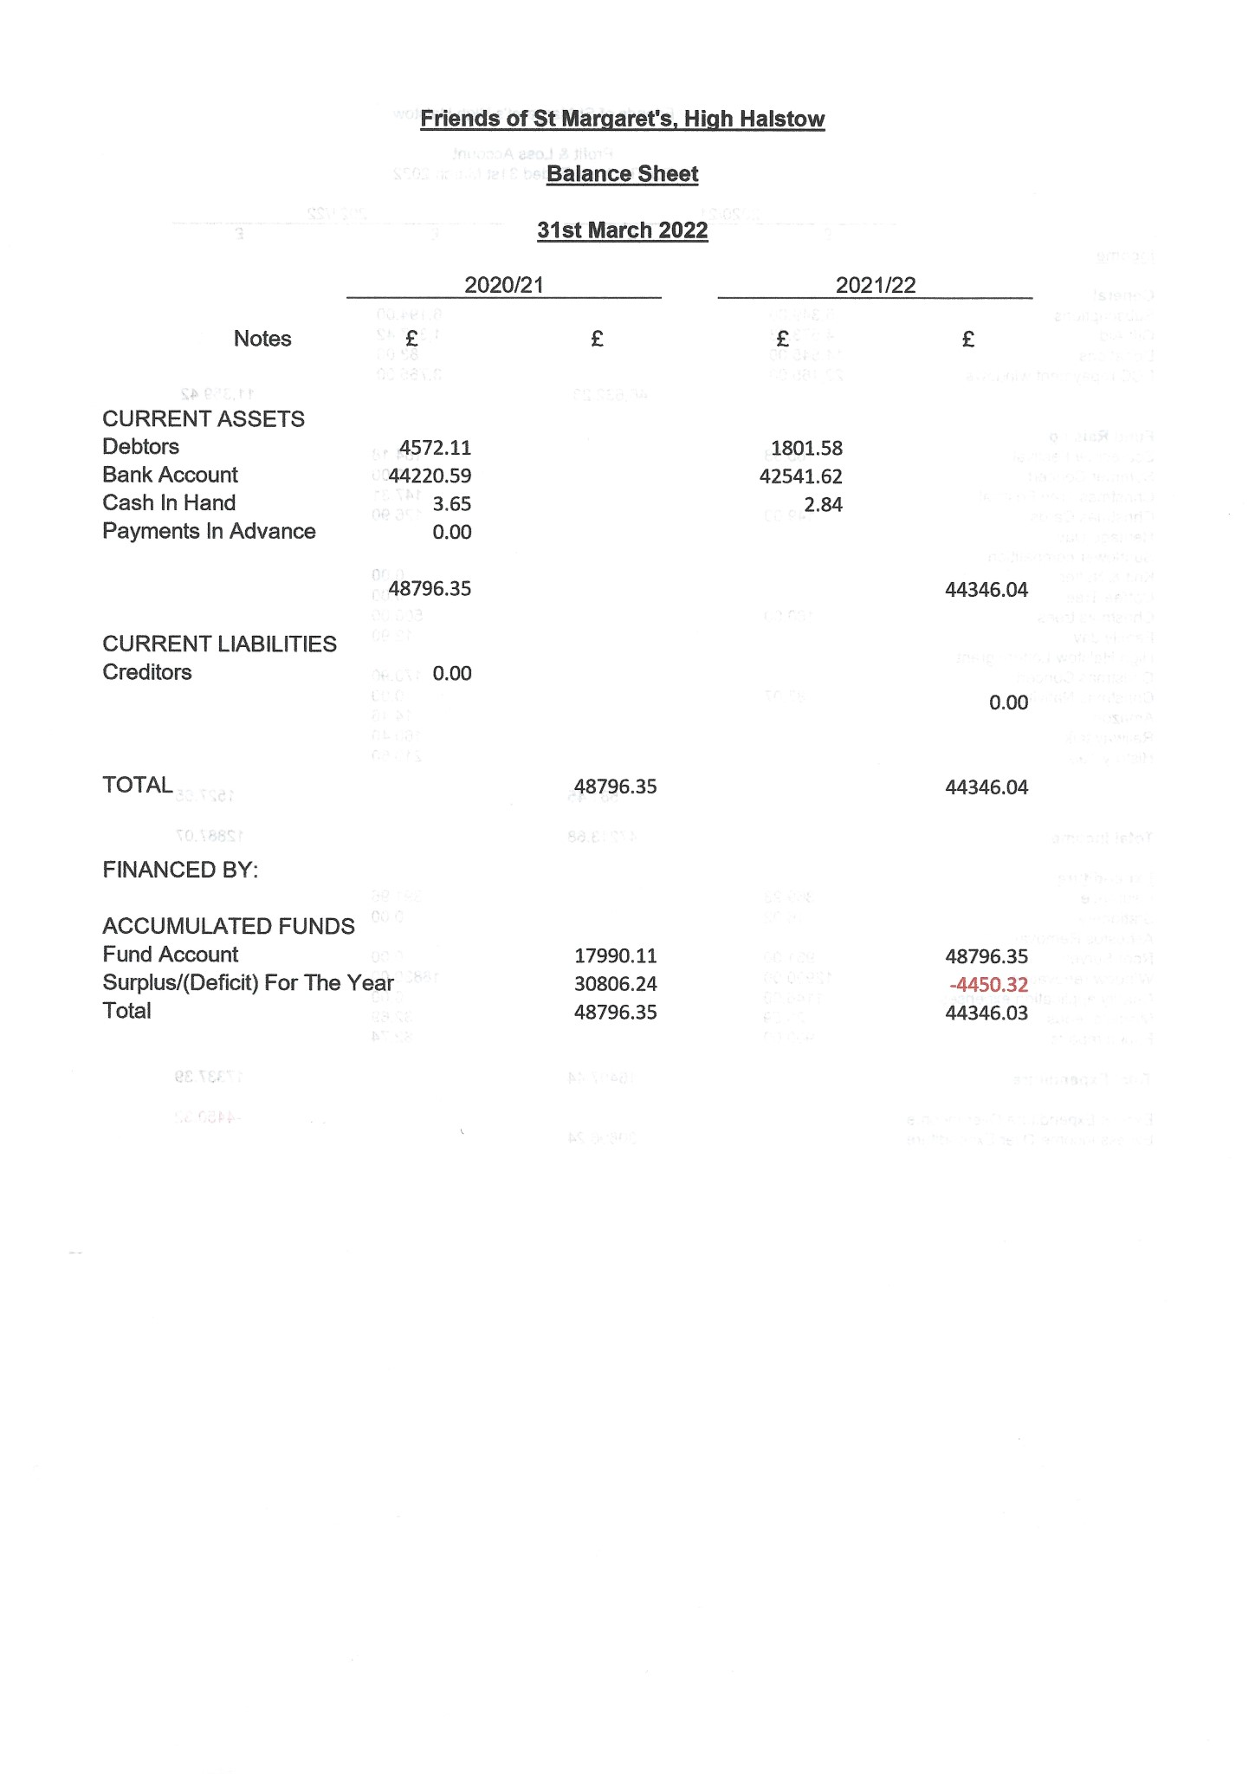
Page 5
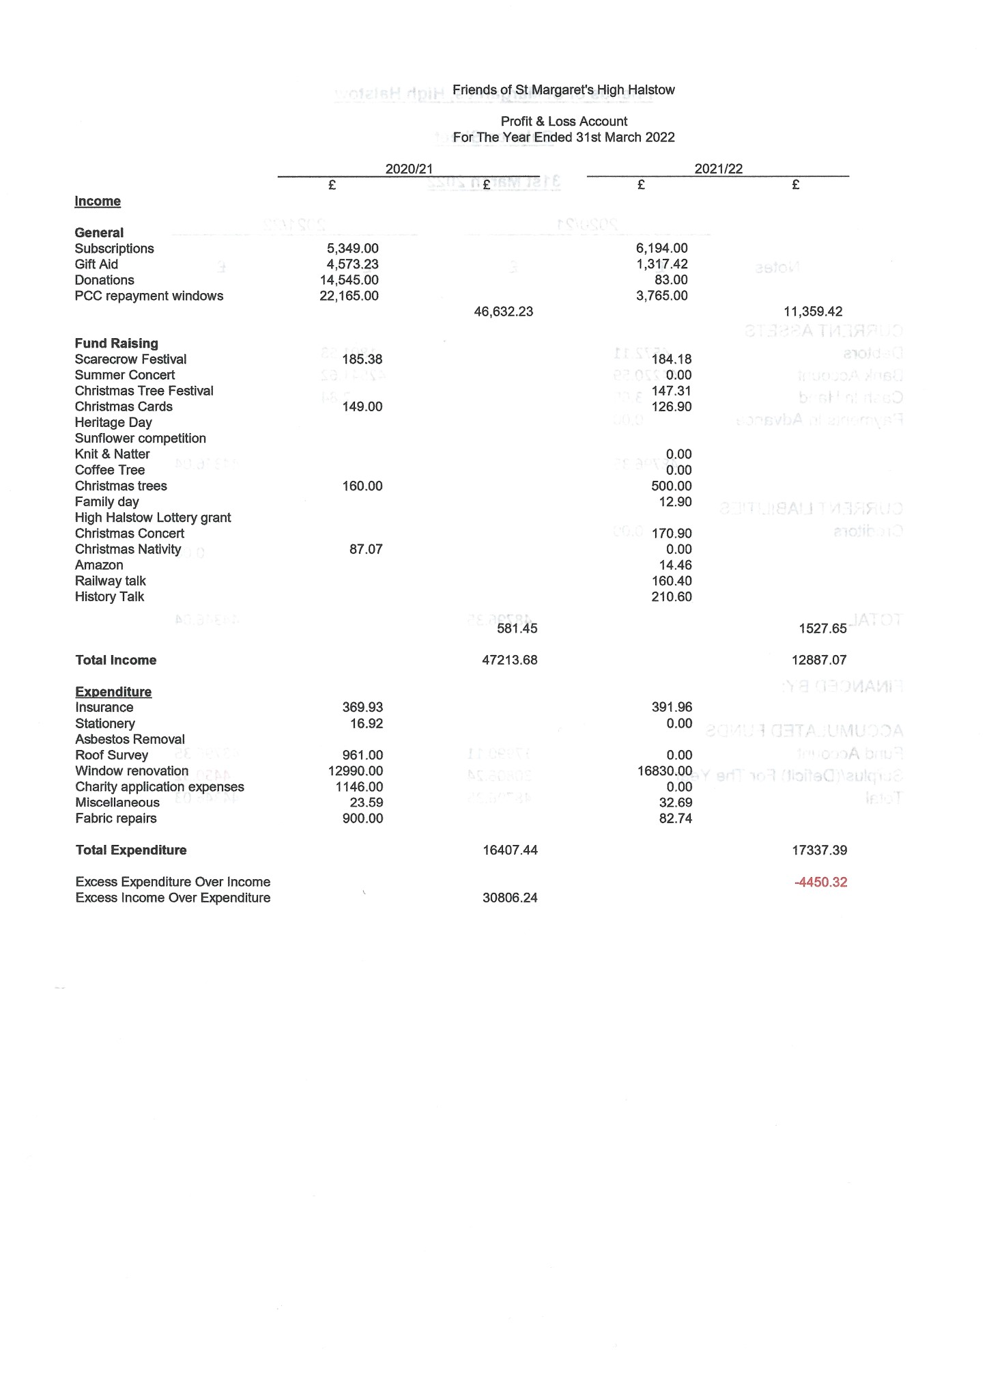
Page 6

